Spring Core Assignments

1) Create an Address class with the following attributes:- street, city, state, zip, country

Create an Customer class with the following attributes:- customerId, customerName,

customerContact, customerAddress.

Inject the Address bean into Customer bean using setter injection

Create a Test class with main() method, get Customer bean from ApplicationContext

object and print details of Customer.

Also write the JUnit Test cases for above program.

- Modify the above application and inject the bean using constructor injection

- Use XML based Configuraion.

Address class

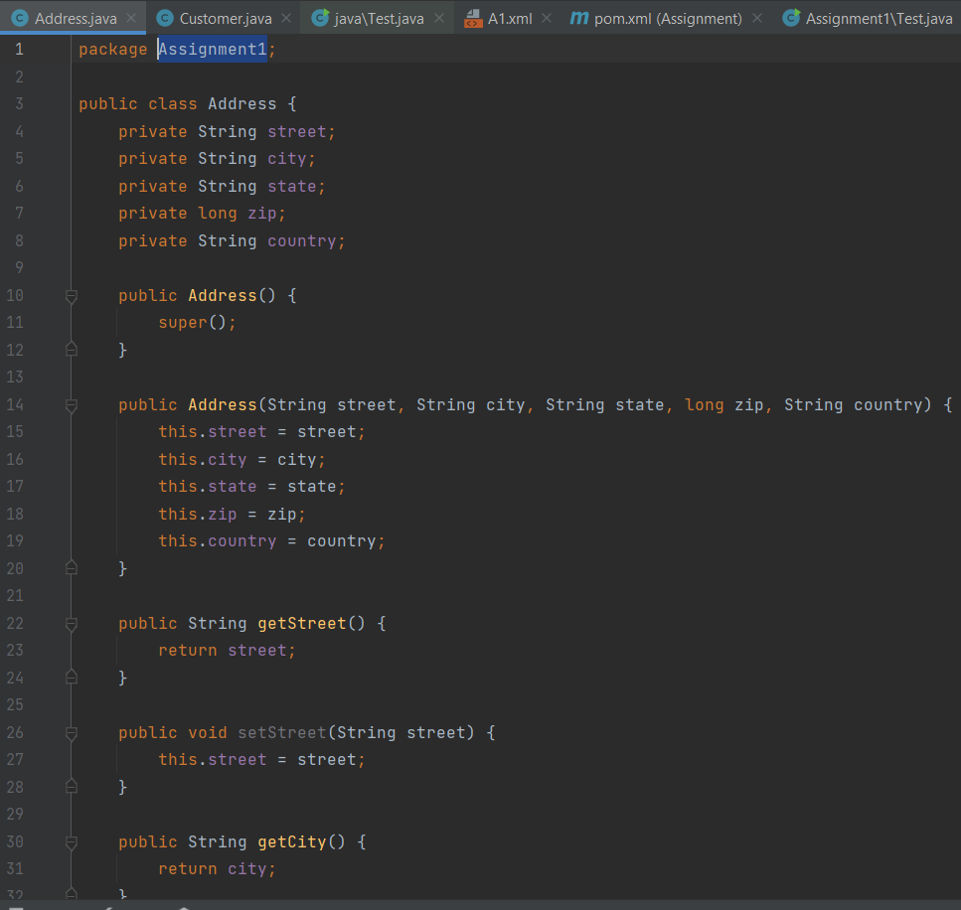

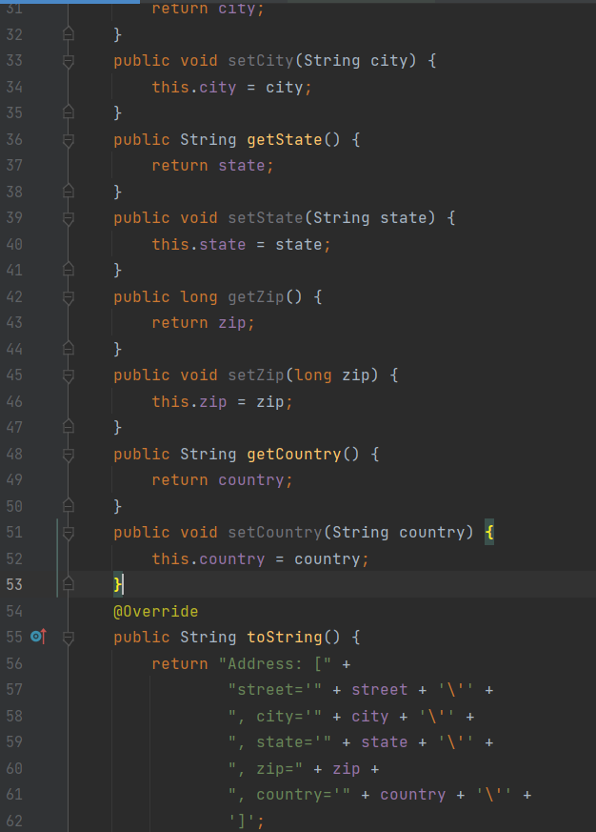

Customer class:

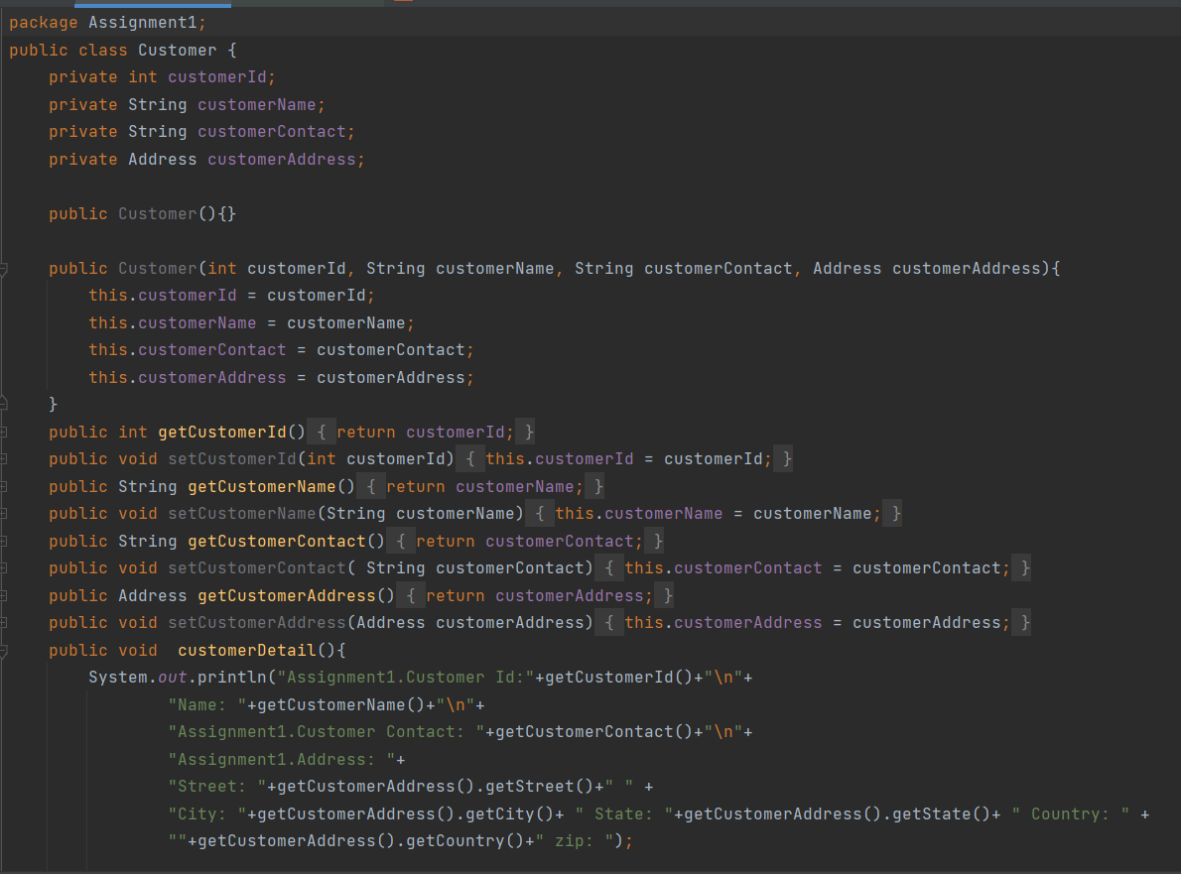

Xml file:

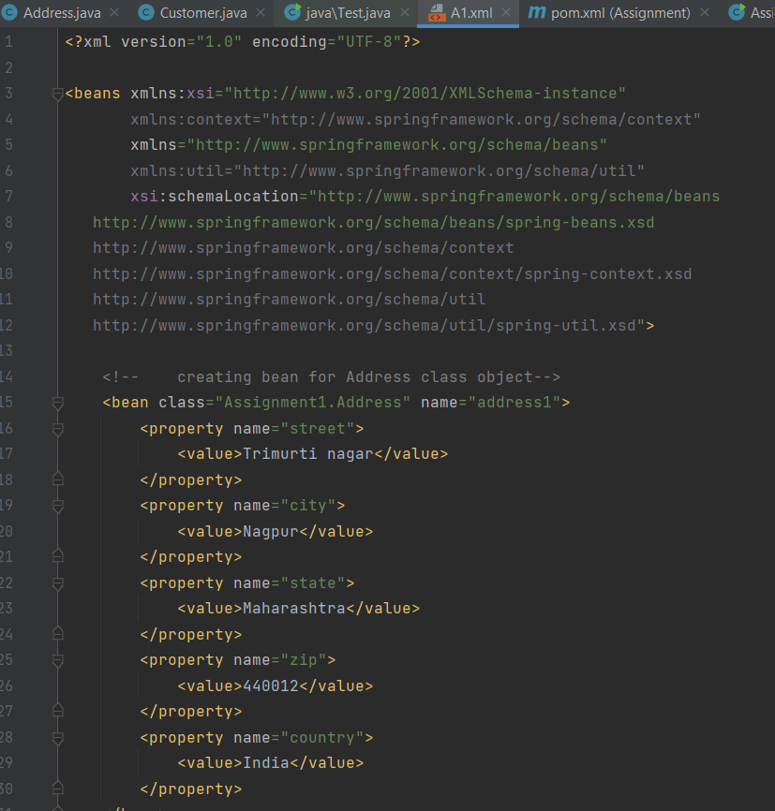

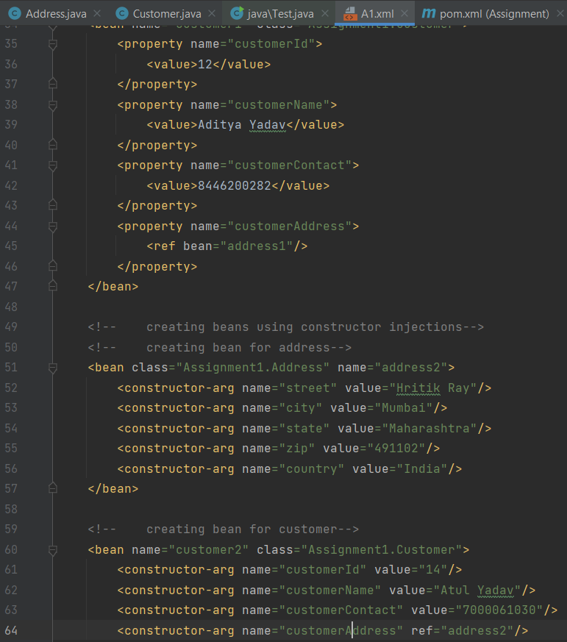

Pom.xml

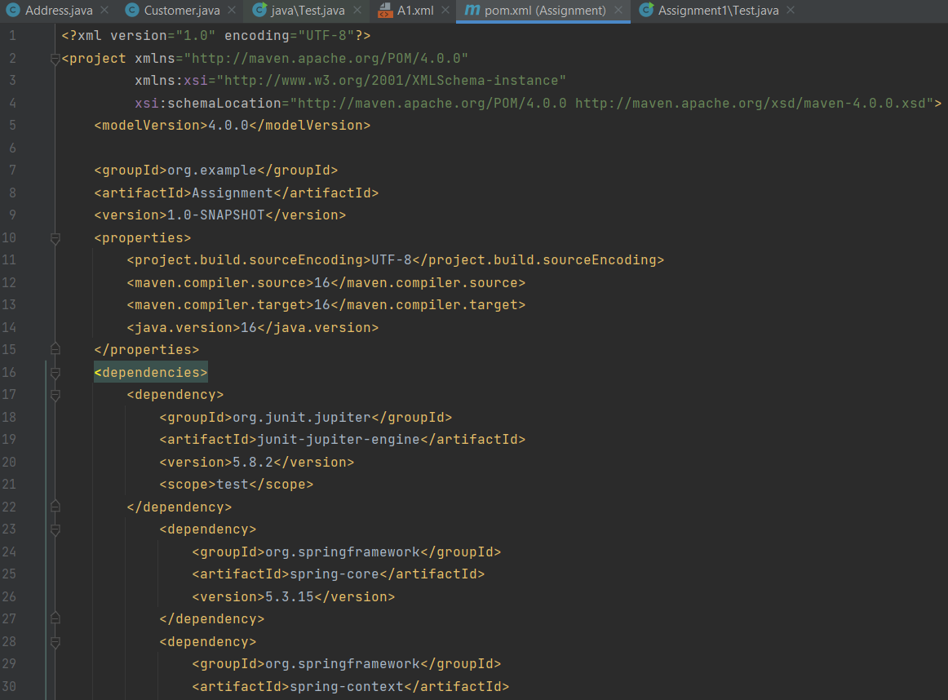

Test.java

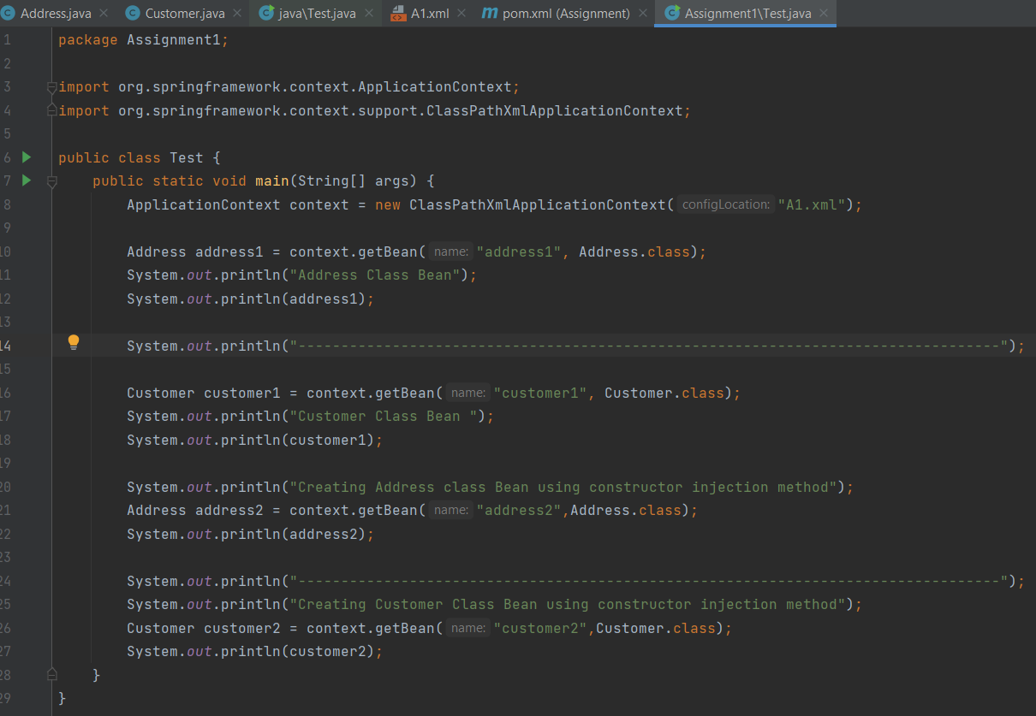

Output:

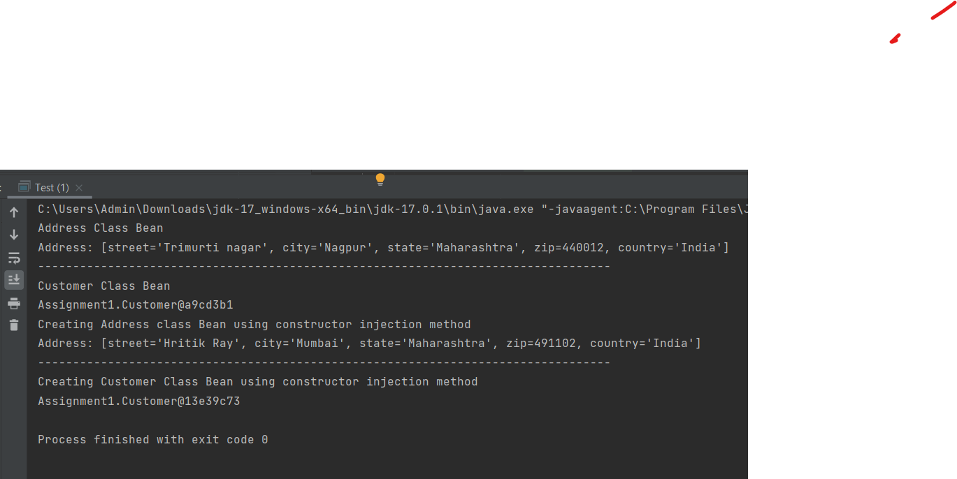

2) Example of Injecting collections (List, Set and Map)

Create a class Question with following attributes: questionId, question, answers.

There are 3 cases for above program.

a. Write a program where answers is of type List<String> or String []

b. Write a program where answers is of type Set<String>

c. Write a program where answers is of type Map<Integer, String>

In case of Map, Integer value represents answer’s sequence number.

d. Create a Test class with main() method, get Question bean from

ApplicationContext object and print question and its answers.

e. Also write the JUnit Test cases for above program.

- Use XML based configuration.

Question1:

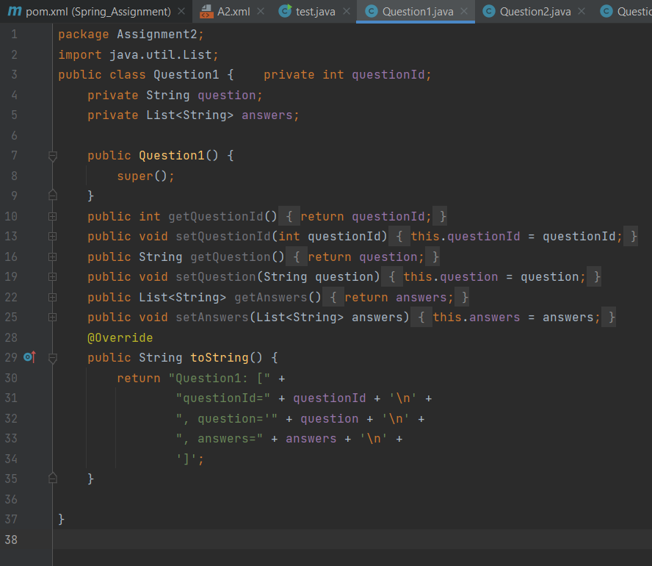

Question2:

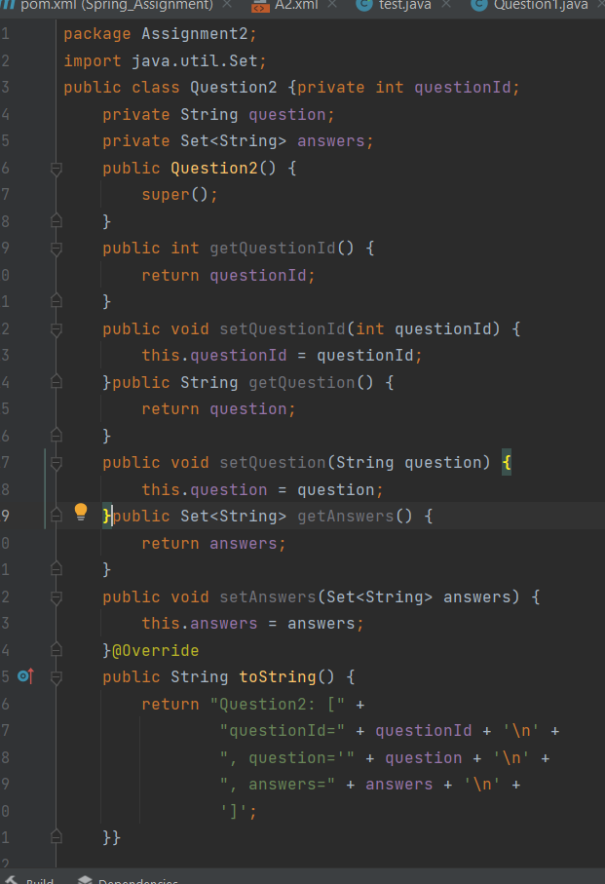

Question3:

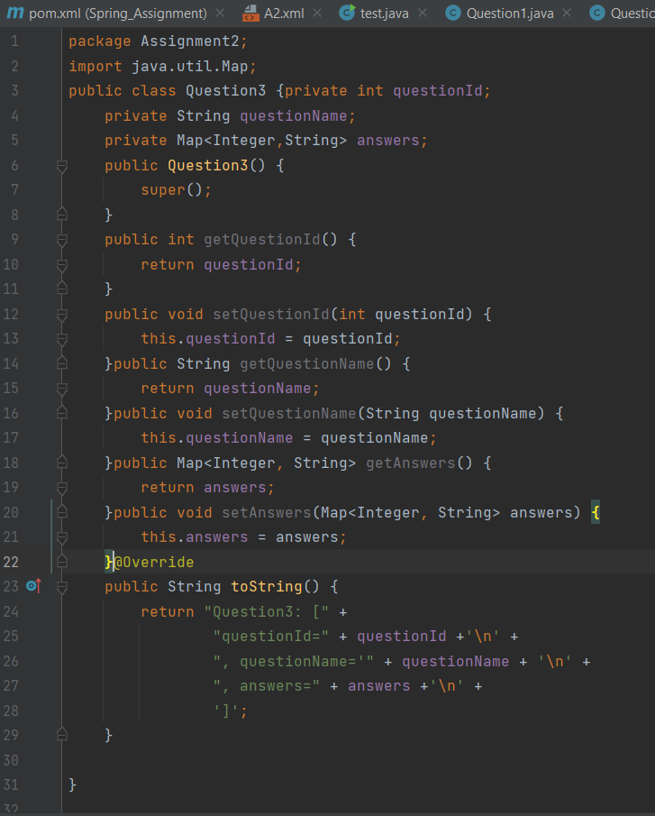

Test.java

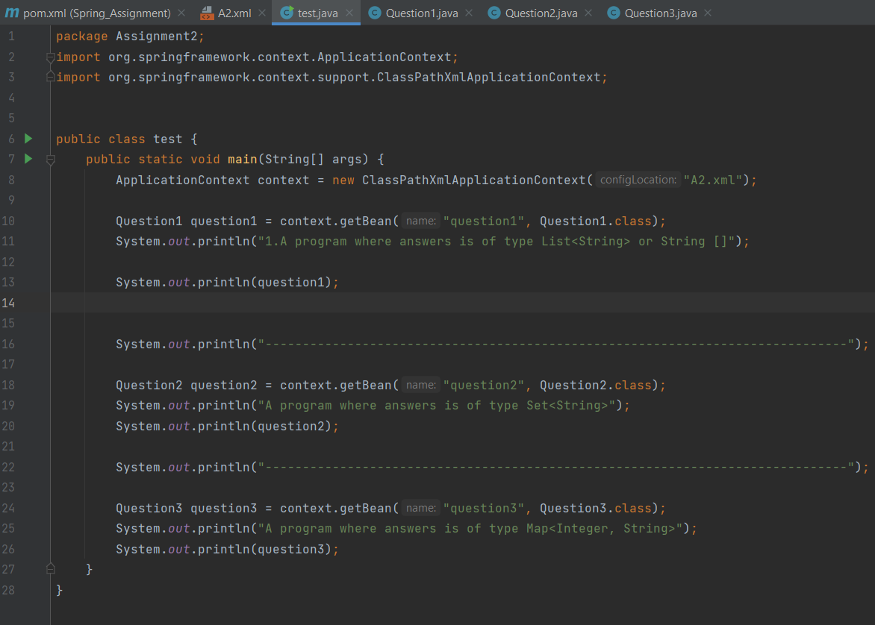

Assignment2.xml

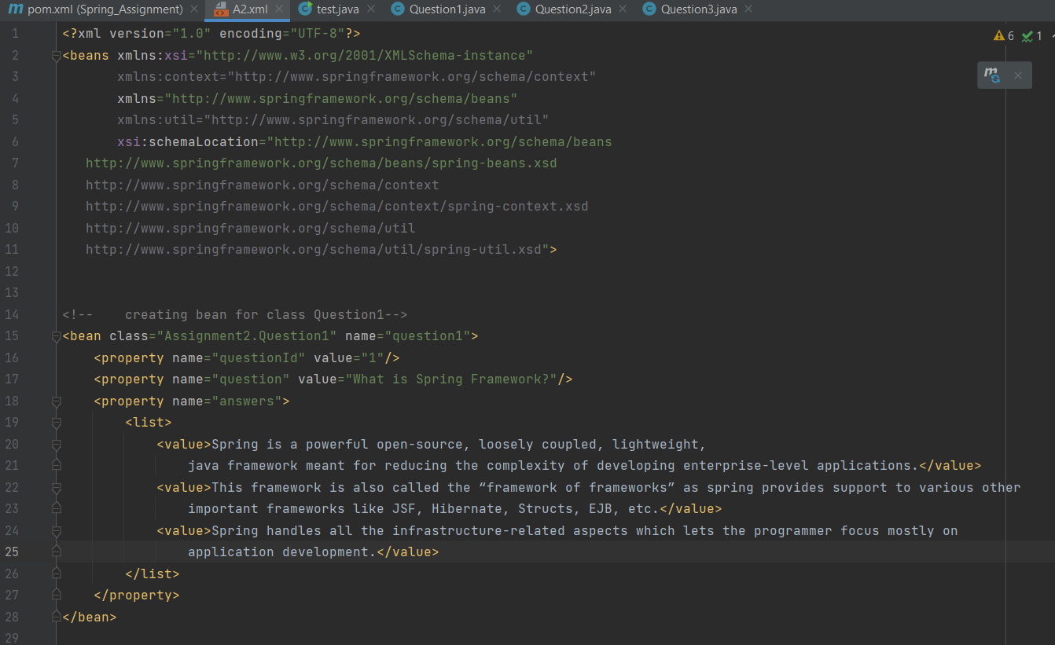

Output:

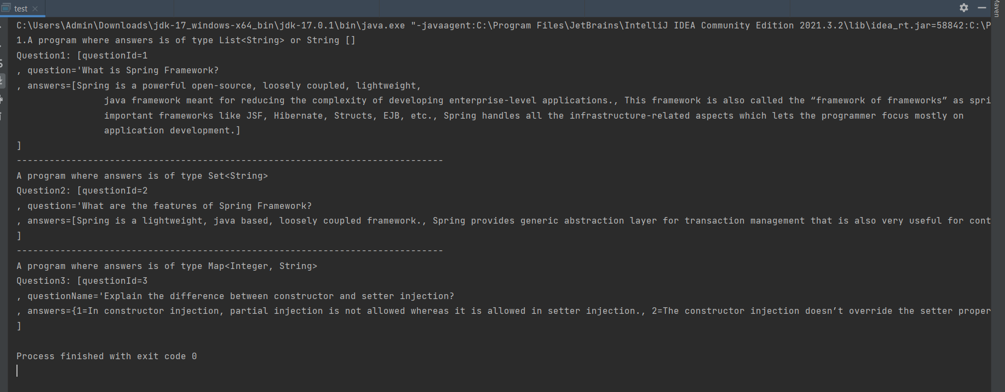

3) Example on autowiring

Design and Develop a Banking Application as follows:

a. Create a BankAccount class with following attributes: accountId,

accountHolderName, accountType, accountBalance

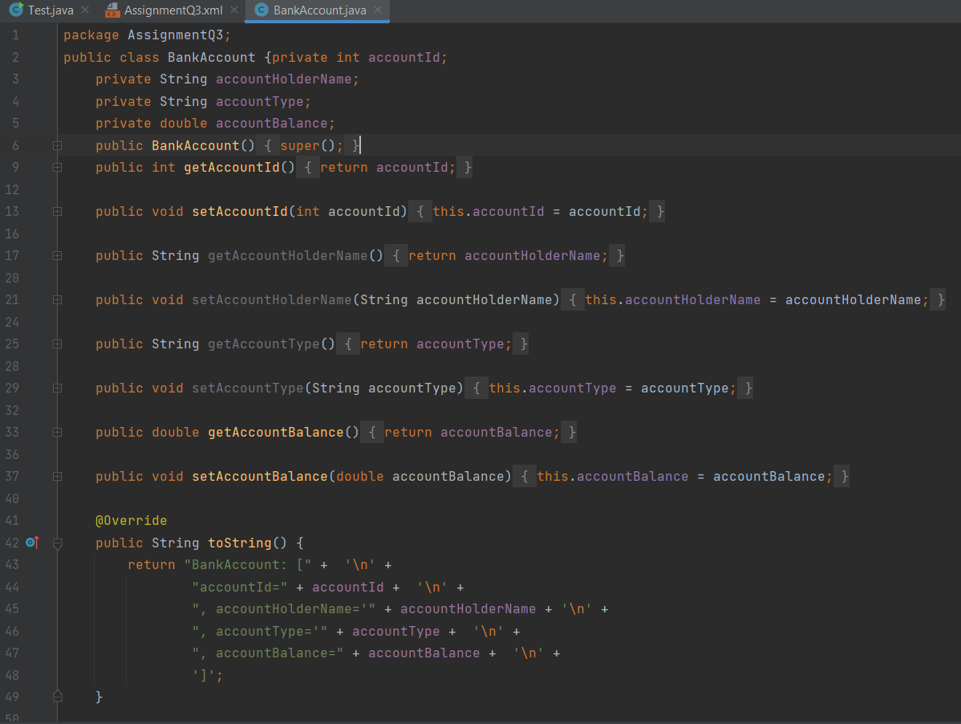

b. Create an interface BankAccountRepository with following methods:

public double getBalance(long accountId)

public double updateBalance(long accountId, double newBalance):

Note: Above method returns updated balance.

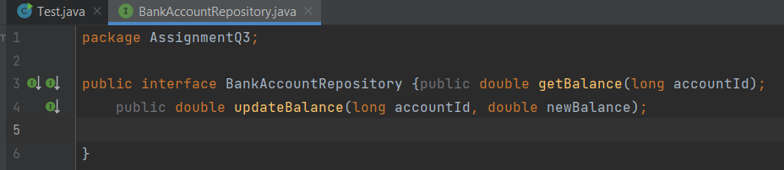

c. Create a class BankAccountepositoryImpl that implements

BankAccountRepository interface.

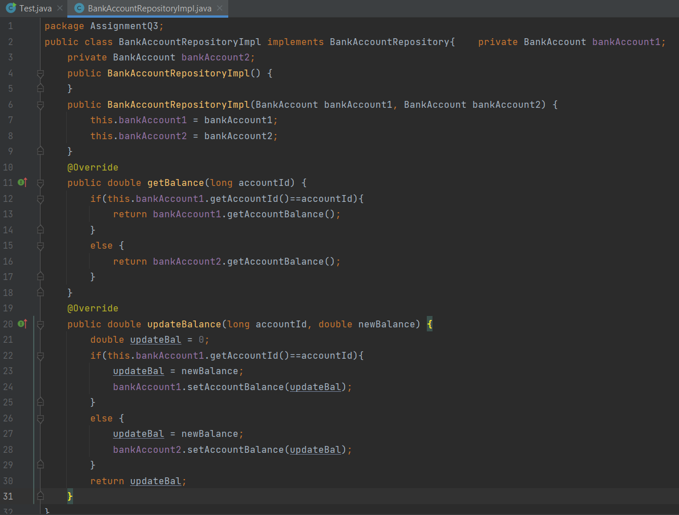

You can use database or any collection object as persistence store.

d. Create an interface BankAccountService with following methods:

public double withdraw(long accountId, double balance)

public double deposit(long accountId, double balance)

public double getBalance(long accountId)

public boolean fundTransfer(long fromAccount, long toAccount, double amount) 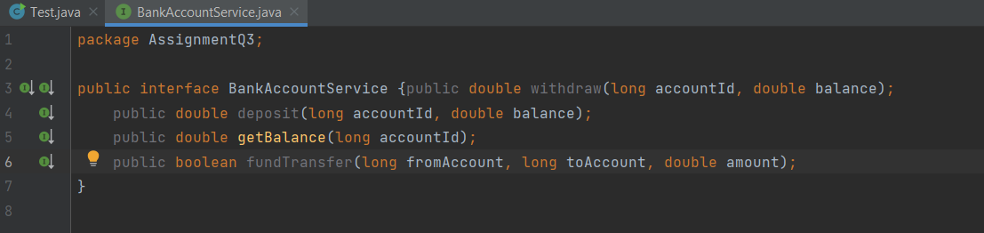

e. Create a class BankAccountServiceImpl that implements BankAccountService

interface.

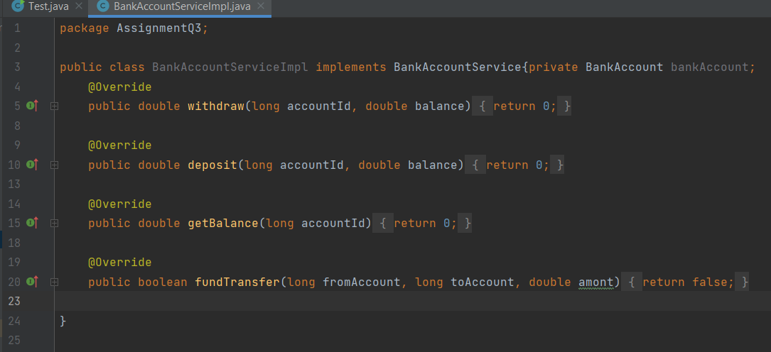

f. Create a class BankAccount controller with following operations:

public double withdraw(long accountId, double balance)

public double deposit(long accountId, double balance)

public double getBalance(long accountId)

public boolean fundTransfer(long fromAccount, long toAccount, double amont)

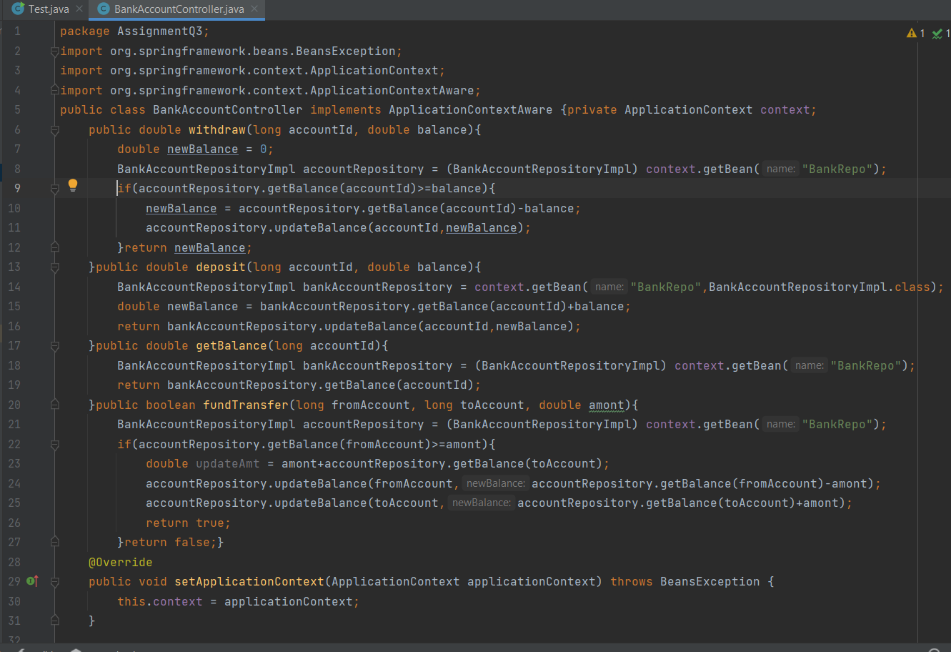

g. Create a Test class with main() method, get BankAccountController bean object

from ApplicationContext and perform all the operations.

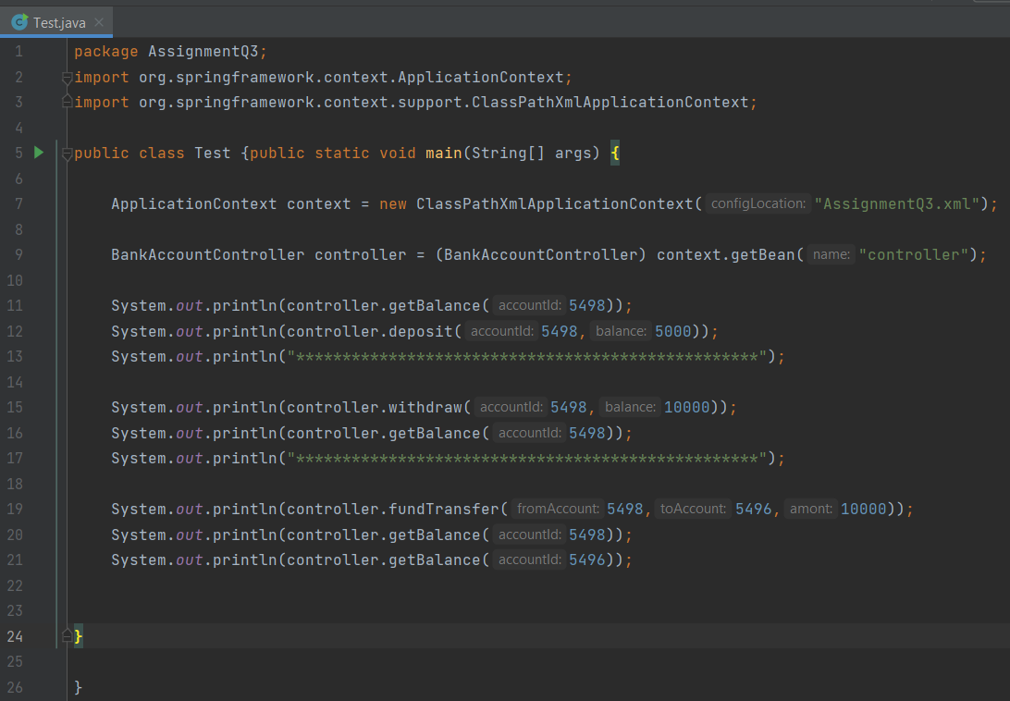

h. Also write the JUnit Test cases for above program.

- Use XML based configuration and perform autowiring with different types.

(byName, byType and constructor). Use one autowiring type at a time.

XML File:

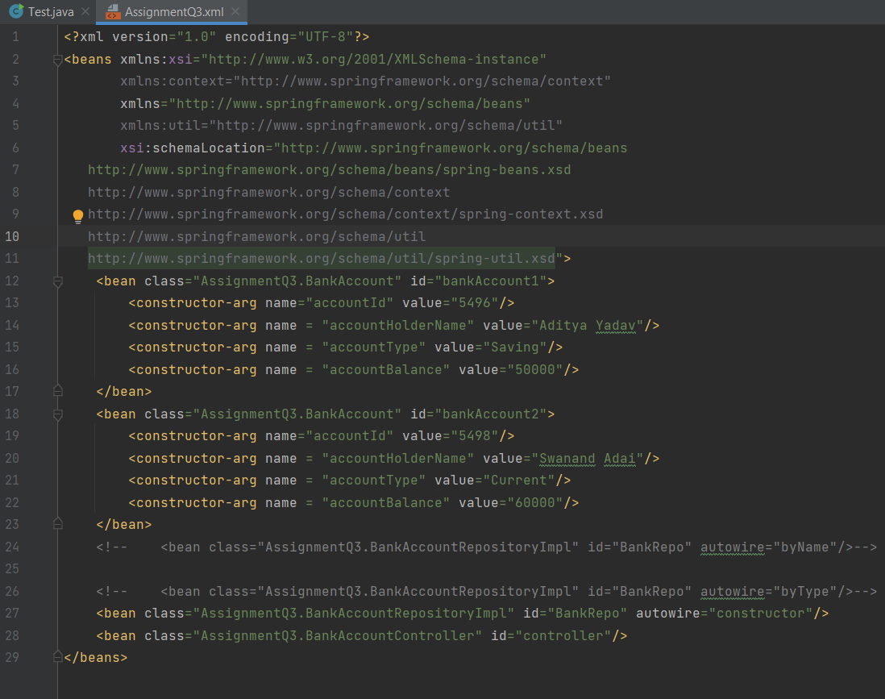

4) Example on @Controller, @Service, @Repository, @Autowired, @Configuration and

@Bean

Modify the above application, use annotations and java based configuration.

BankAccount.java:

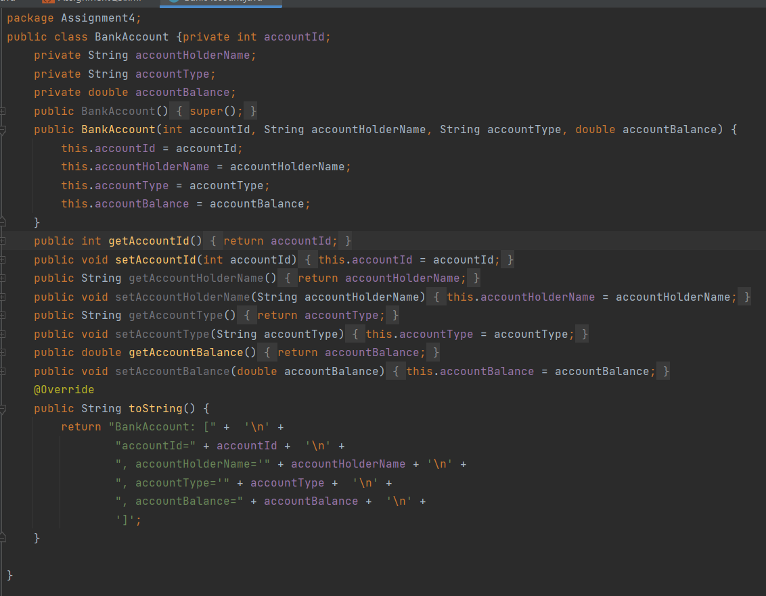

BankAccountController.java:

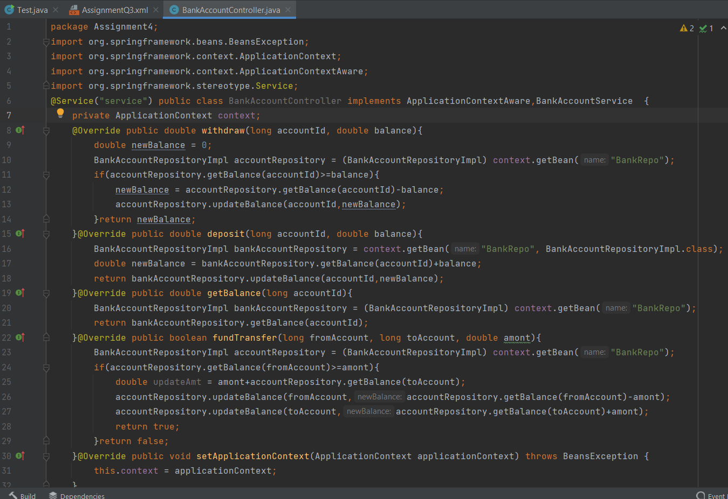

package Assignment4;  
  
public interface BankAccountRepository {public double getBalance(long accountId);  
 public double updateBalance(long accountId, double newBalance);  
  
}

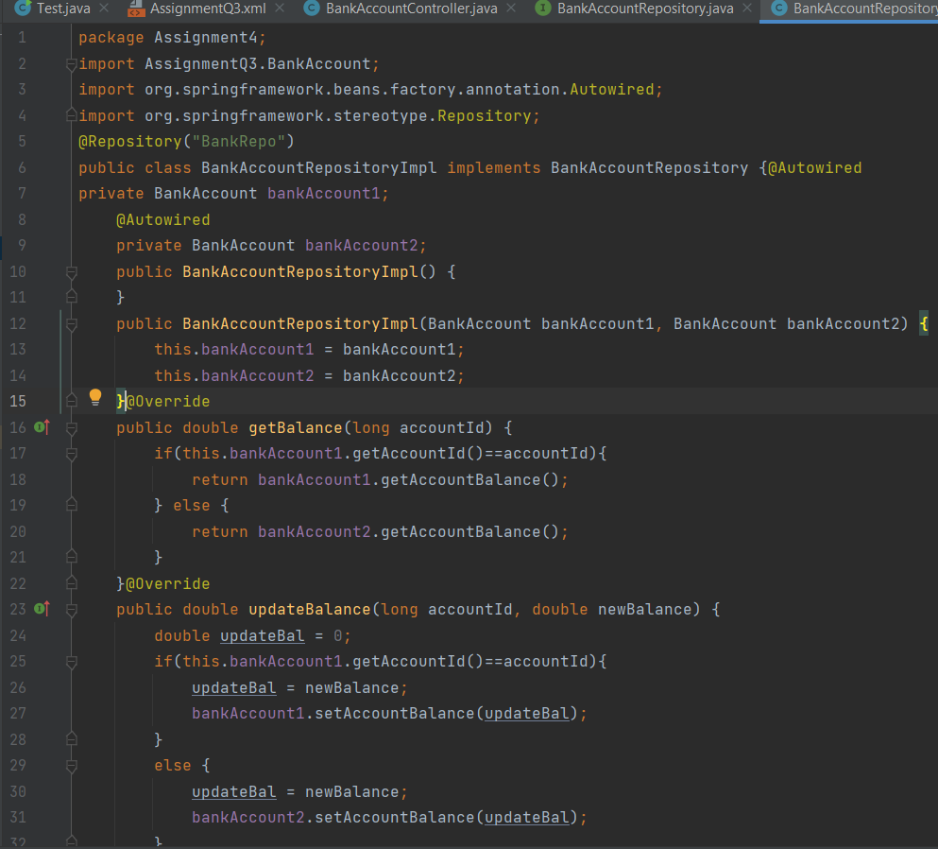

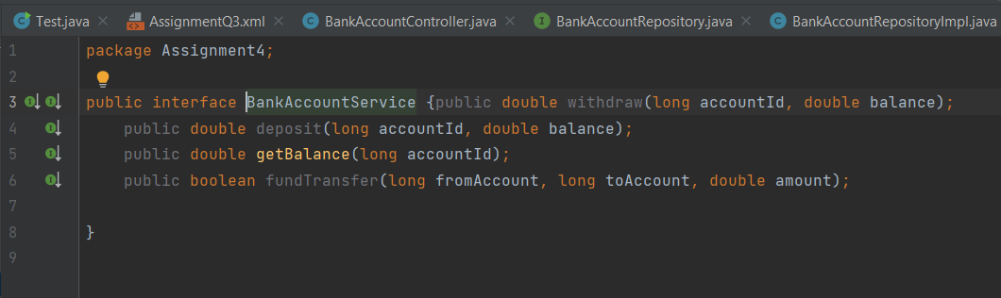

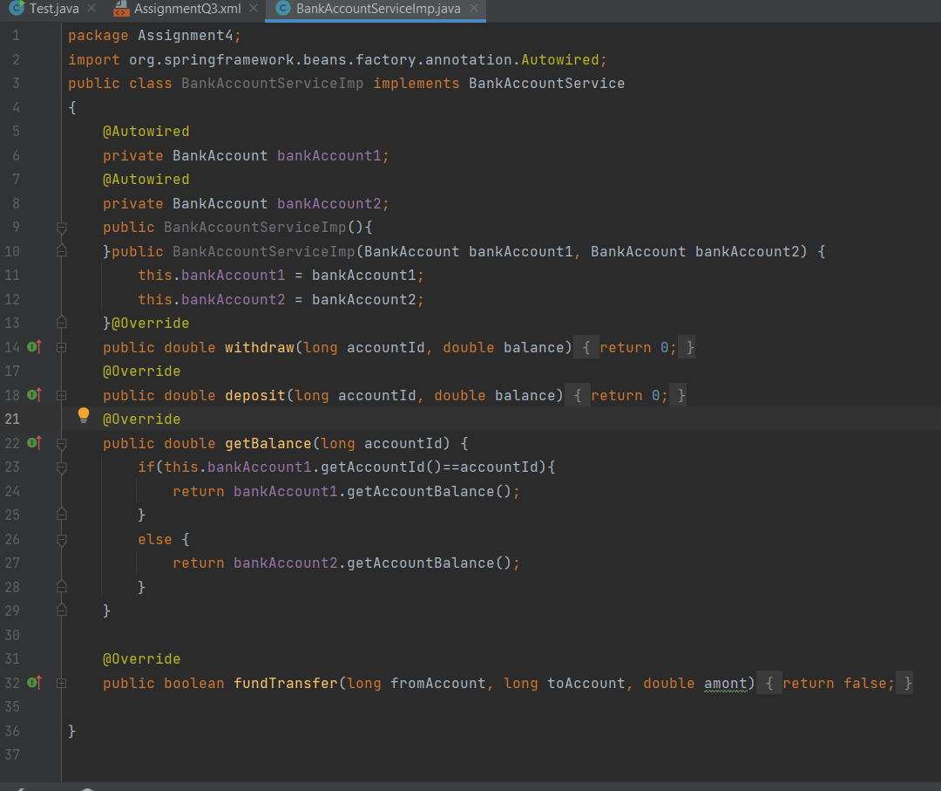

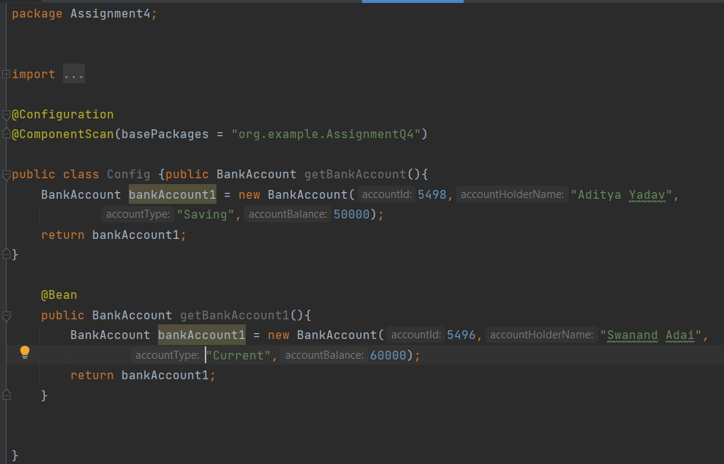

Output:

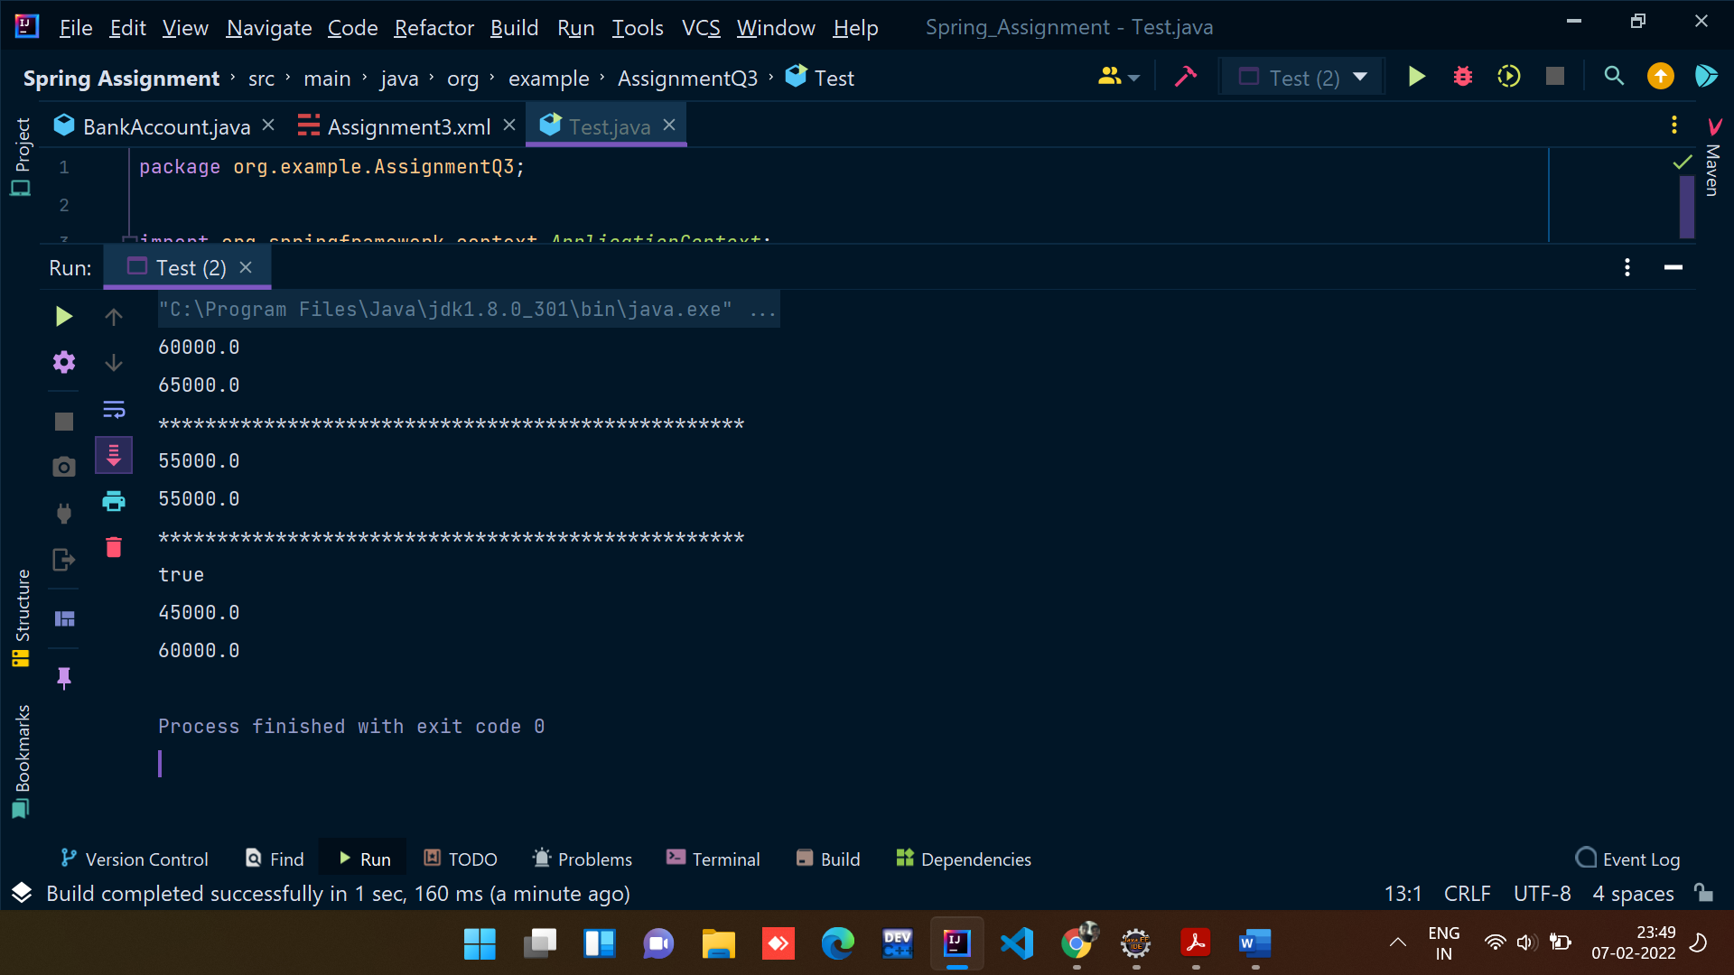

7) Write a Java program to demonstrate SPEL (Spring Expression language)

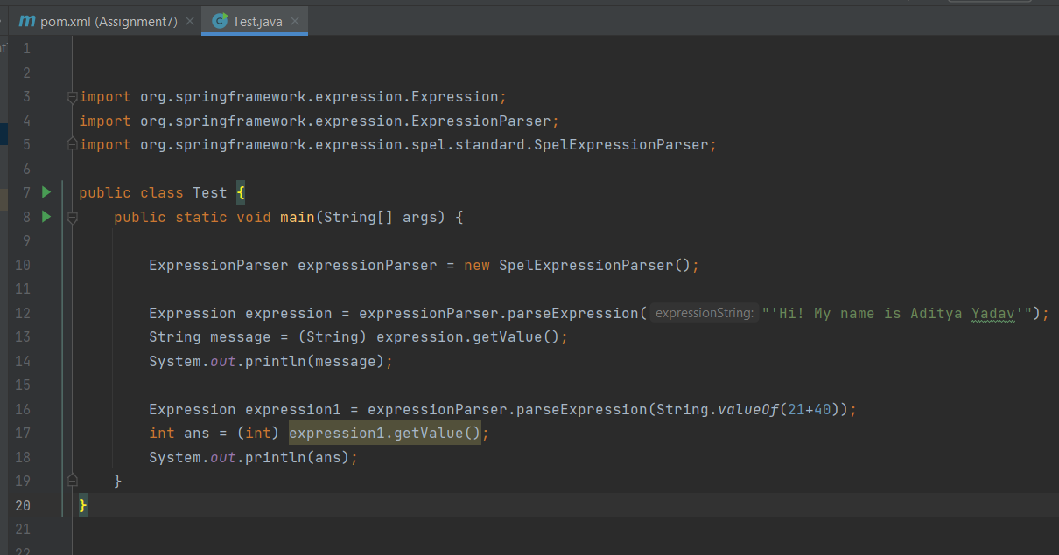

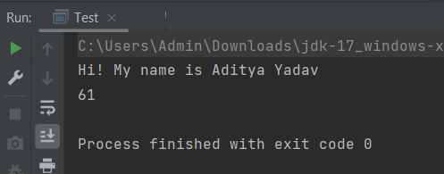

8) Write a Java program to demonstrate InitializingBean and DisposableBean.

Try Different ways:

(Use init-method and destroy-method in xml config file)

(Use @PostConstruct and @PreDestroy)

9) Write a Java program to demonstrate Complete Bean Life cycle.

AnnotationBeanLifeCyle class:

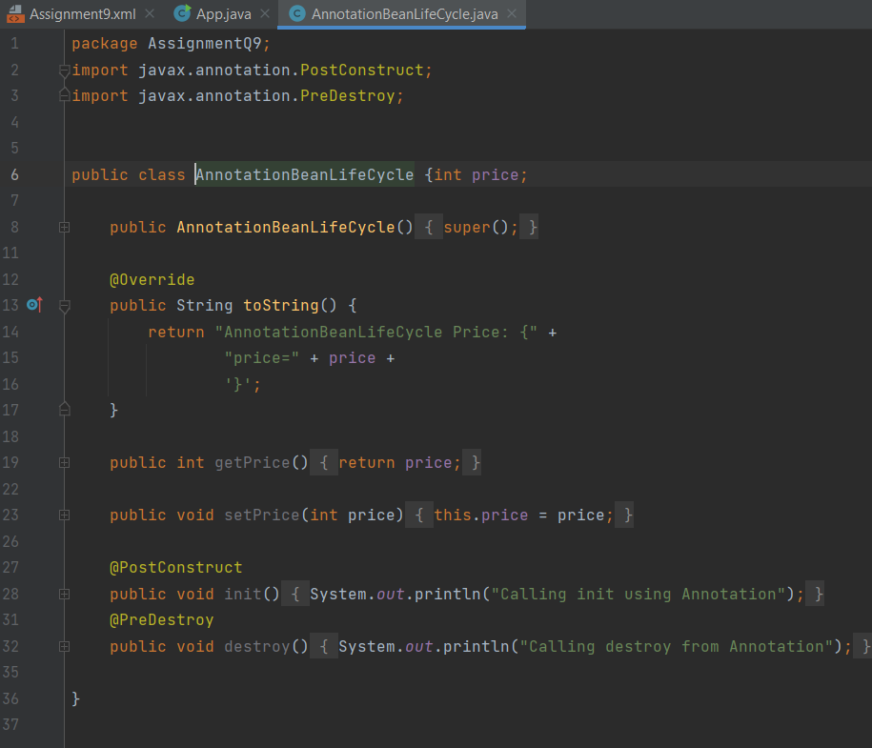

InterfaceBeanLifeCycle:

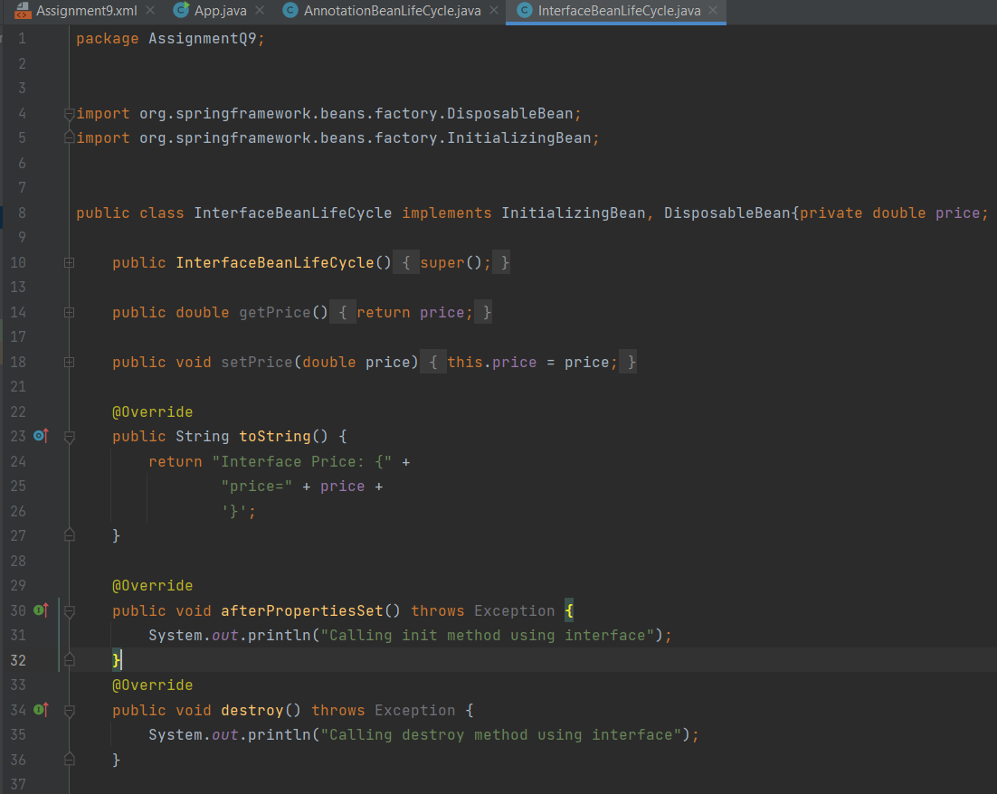

XML BeanLife:

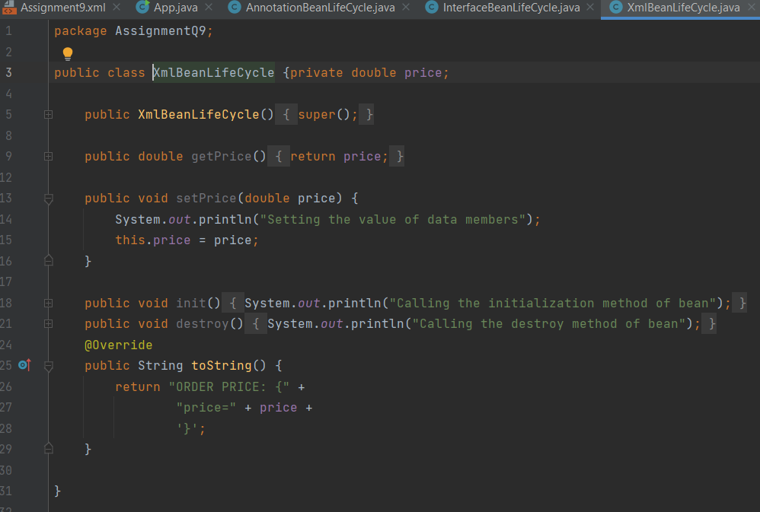

XML file:

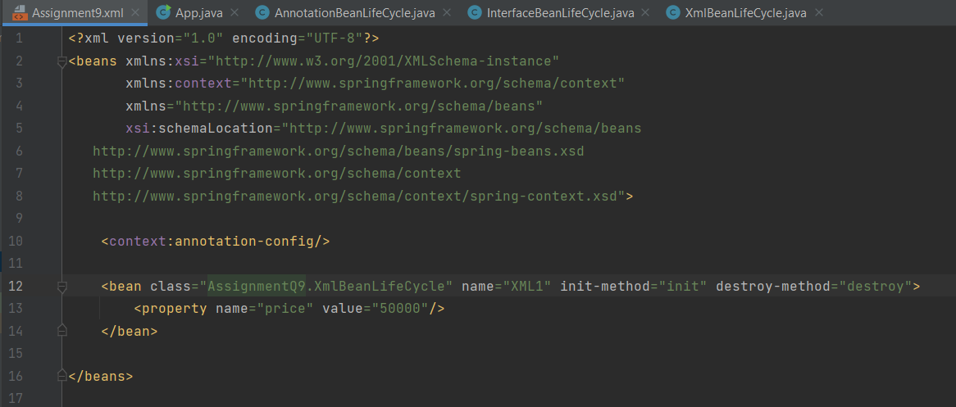

Output:

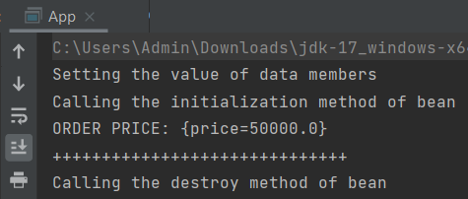

10) Write a java program to demonstrate ApplicationContextAware interface.

Demo class:

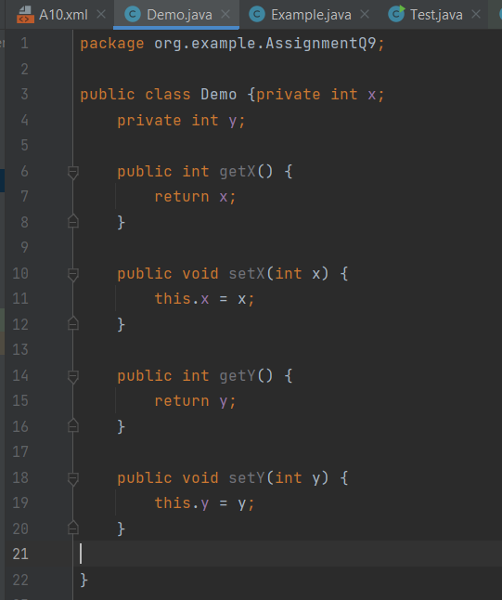

Example.java:

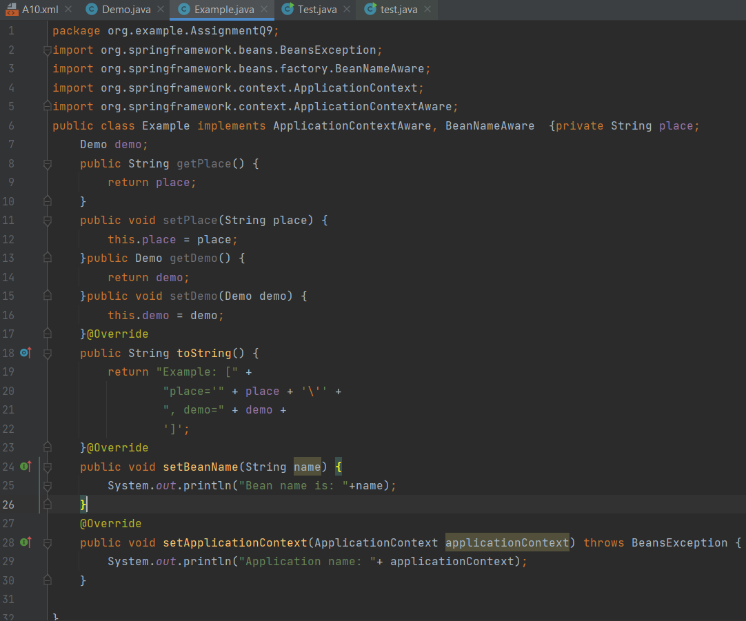

Test:

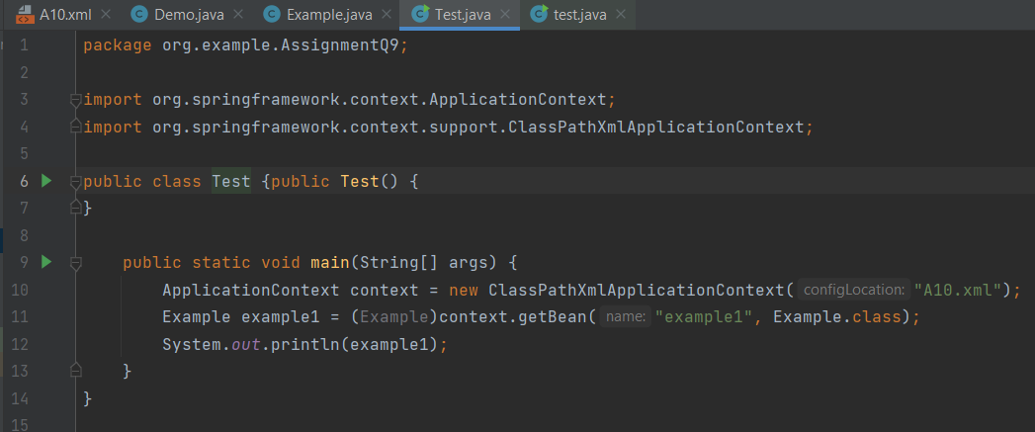

Xml:

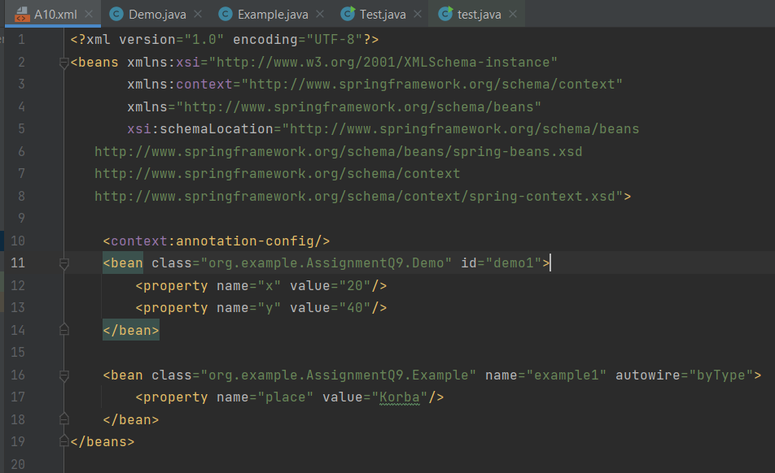

Output:

